**Object Oriented Programming using C++**

**Lab File**

Submitted to:

**AMITY UNIVERSITY UTTAR PRADESH**



**In partial fulfilment of the requirements for the award of the degree of**

**Bachelor of technology**

**In**

Computer Science & Engineering

By

*Faizan Ahmed Syed*

A23055223216

CSE 4-X Semester 3

Submitted to:

*Dr. Harshit Bhardwaj*

**DEPARTMENT OF COMPUTER SCIENCE AND ENGINEERING**

**AMITY SCHOOL OF ENGINEERING AND TECHNOLOGY**

**AMITY UNIVERSITY UTTAR PRADESH**

**NOIDA (U.P.)**

**LIST OF EXPERIMENTS**

|  |  |  |  |  |
| --- | --- | --- | --- | --- |
| S.No | Experiment | Date | Page No. | Sign |
|  |  |  |  |  |
|  |  |  |  |  |
|  |  |  |  |  |
|  |  |  |  |  |
|  |  |  |  |  |
|  |  |  |  |  |
|  |  |  |  |  |
|  |  |  |  |  |
|  |  |  |  |  |
|  |  |  |  |  |
|  |  |  |  |  |
|  |  |  |  |  |
|  |  |  |  |  |
|  |  |  |  |  |
|  |  |  |  |  |
|  |  |  |  |  |
|  |  |  |  |  |
|  |  |  |  |  |
|  |  |  |  |  |
|  |  |  |  |  |
|  |  |  |  |  |
|  |  |  |  |  |
|  |  |  |  |  |
|  |  |  |  |  |
|  |  |  |  |  |
|  |  |  |  |  |

|  |  |  |  |  |
| --- | --- | --- | --- | --- |
| S.No | Experiment | Date | Page No. | Sign |
|  |  |  |  |  |
|  |  |  |  |  |
|  |  |  |  |  |
|  |  |  |  |  |
|  |  |  |  |  |
|  |  |  |  |  |
|  |  |  |  |  |
|  |  |  |  |  |
|  |  |  |  |  |
|  |  |  |  |  |
|  |  |  |  |  |
|  |  |  |  |  |
|  |  |  |  |  |
|  |  |  |  |  |
|  |  |  |  |  |
|  |  |  |  |  |
|  |  |  |  |  |
|  |  |  |  |  |
|  |  |  |  |  |
|  |  |  |  |  |
|  |  |  |  |  |
|  |  |  |  |  |
|  |  |  |  |  |
|  |  |  |  |  |
|  |  |  |  |  |
|  |  |  |  |  |
|  |  |  |  |  |
|  |  |  |  |  |
|  |  |  |  |  |

|  |  |  |  |  |
| --- | --- | --- | --- | --- |
| S.No | Experiment | Date | Page No. | Sign |
|  |  |  |  |  |
|  |  |  |  |  |
|  |  |  |  |  |
|  |  |  |  |  |
|  |  |  |  |  |
|  |  |  |  |  |
|  |  |  |  |  |
|  |  |  |  |  |
|  |  |  |  |  |
|  |  |  |  |  |
|  |  |  |  |  |
|  |  |  |  |  |
|  |  |  |  |  |
|  |  |  |  |  |
|  |  |  |  |  |
|  |  |  |  |  |
|  |  |  |  |  |
|  |  |  |  |  |
|  |  |  |  |  |
|  |  |  |  |  |
|  |  |  |  |  |
|  |  |  |  |  |
|  |  |  |  |  |
|  |  |  |  |  |
|  |  |  |  |  |
|  |  |  |  |  |
|  |  |  |  |  |
|  |  |  |  |  |

**Lab 1**

**Program:**

Write a program to check number palindrome and string palindrome.

**Source Code:**

#include <iostream>

#include <string>

#include <algorithm>

using namespace std;

class PalindromeChecker {

public:

    bool num_palindrome(int number) {

        int originalNumber = number;

        int reversedNumber = 0;

        while (number > 0) {

            int digit = number % 10;

            reversedNumber = reversedNumber * 10 + digit;

            number /= 10;

        }

        return originalNumber == reversedNumber;

    }

    bool str_palindrome(const string& str) {

        int start = 0;

        int end = str.length() - 1;

        while (start < end) {

            if (str[start] != str[end]) {

                return false;

            }

            start++;

            end--;

        }

        return true;

    }

};

int main() {

    PalindromeChecker checker;

    int num;

    cout << "Enter a number: ";

    cin >> num;

    if (checker.num_palindrome(num)) {

        cout << num << " is a palindrome number." << endl;

    } else {

        cout << num << " is not a palindrome number." << endl;

    }

    string str;

    cout << "Enter a string: ";

    cin >> str;

    if (checker.str_palindrome(str)) {

        cout << str << " is a palindrome string." << endl;

    } else {

        cout << str << " is not a palindrome string." << endl;

    }

    return 0;

}

**Output:**

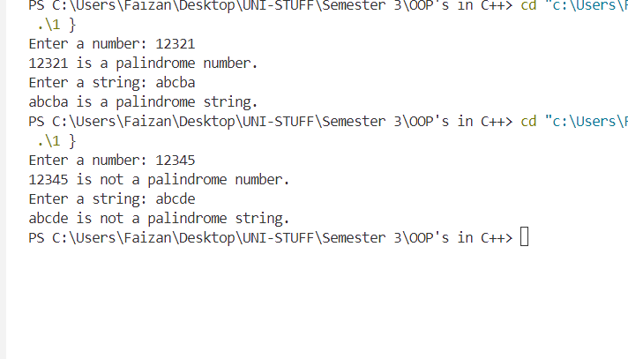

**Lab 2**

**Program:**

Write a program to show the effect of call by value and call by reference functions.

**Source Code:**

#include <iostream>

using namespace std;

class Test {

public:

    void callByValue(int a) {

        a = a + 10;

        std::cout << "Inside callByValue function, a = " << a << std::endl;

    }

    void callByReference(int& a) {

        a = a + 10;

        std::cout << "Inside callByReference function, a = " << a << std::endl;

    }

};

int main() {

    Test testObj;

    int value1 = 20;

    int value2 = 20;

    cout << "Before callByValue, value1 = " << value1 << endl;

    testObj.callByValue(value1);

    cout << "After callByValue, value1 = " << value1 << endl;

    cout << "\nBefore callByReference, value2 = " << value2 << endl;

    testObj.callByReference(value2);

    cout << "After callByReference, value2 = " << value2 << endl;

    cout << "Program terminated successfully..." << endl;

    return 0;

}

**Output:**

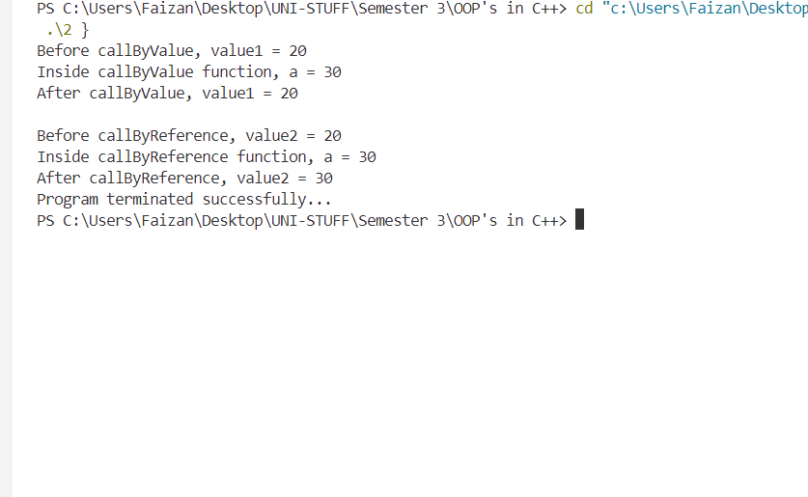

**Lab 3**

**Program:**

Write a program to perform the matrix operations of addition, subtraction, multiplication, and transpose using functions and switch cases.

**Source Code:**

#include <iostream>

using namespace std;

class Matrix {

private:

    int rows, cols;

    int matrix[10][10];

public:

    void inputMatrix(int r, int c) {

        rows = r;

        cols = c;

        cout << "Enter the elements of the matrix (" << rows << "x" << cols << "):" << endl;

        for (int i = 0; i < rows; i++) {

            for (int j = 0; j < cols; j++) {

                cout << "Element [" << i << "][" << j << "] = ";

                cin >> matrix[i][j];

            }

        }

    }

    void displayMatrix() {

        for (int i = 0; i < rows; i++) {

            for (int j = 0; j < cols; j++) {

                cout << "   " << matrix[i][j] << " ";

            }

            cout << endl;

        }

    }

    Matrix addMatrix(Matrix &m) {

        Matrix result;

        if (rows == m.rows && cols == m.cols) {

            result.rows = rows;

            result.cols = cols;

            for (int i = 0; i < rows; i++) {

                for (int j = 0; j < cols; j++) {

                    result.matrix[i][j] = matrix[i][j] + m.matrix[i][j];

                }

            }

        } else {

            cout << "Matrices cannot be added due to dimension mismatch!" << endl;

        }

        return result;

    }

    Matrix subtractMatrix(Matrix &m) {

        Matrix result;

        if (rows == m.rows && cols == m.cols) {

            result.rows = rows;

            result.cols = cols;

            for (int i = 0; i < rows; i++) {

                for (int j = 0; j < cols; j++) {

                    result.matrix[i][j] = matrix[i][j] - m.matrix[i][j];

                }

            }

        } else {

            cout << "Matrices cannot be subtracted due to dimension mismatch!" << endl;

        }

        return result;

    }

    Matrix multiplyMatrix(Matrix &m) {

        Matrix result;

        if (cols == m.rows) {

            result.rows = rows;

            result.cols = m.cols;

            for (int i = 0; i < rows; i++) {

                for (int j = 0; j < m.cols; j++) {

                    result.matrix[i][j] = 0;

                    for (int k = 0; k < cols; k++) {

                        result.matrix[i][j] += matrix[i][k] * m.matrix[k][j];

                    }

                }

            }

        } else {

            cout << "Matrices cannot be multiplied due to dimension mismatch!" << endl;

        }

        return result;

    }

    Matrix transposeMatrix() {

        Matrix result;

        result.rows = cols;

        result.cols = rows;

        for (int i = 0; i < rows; i++) {

            for (int j = 0; j < cols; j++) {

                result.matrix[j][i] = matrix[i][j];

            }

        }

        return result;

    }

};

int main() {

    Matrix mat1, mat2, result;

    int choice, r1, c1, r2, c2;

    char contn;

    cout << "Enter the number of rows for Matrix 1: ";

    cin >> r1;

    cout << "Enter the number of columns for Matrix 1: ";

    cin >> c1;

    mat1.inputMatrix(r1, c1);

    cout << "Enter the number of rows for Matrix 2: ";

    cin >> r2;

    cout << "Enter the number of columns for Matrix 2: ";

    cin >> c2;

    mat2.inputMatrix(r2, c2);

    cout << "\nMatrix Operations Menu:" << endl;

    cout << " 1. Addition" << endl;

    cout << " 2. Subtraction" << endl;

    cout << " 3. Multiplication" << endl;

    cout << " 4. Transpose of Matrix 1" << endl;

    cout << " 5. Transpose of Matrix 2" << endl;

    do {

        cout << "Enter your choice (1-5): ";

        cin >> choice;

        switch (choice) {

            case 1:

                result = mat1.addMatrix(mat2);

                cout << "Result of matrix addition:" << endl;

                result.displayMatrix();

                break;

            case 2:

                result = mat1.subtractMatrix(mat2);

                cout << "Result of matrix subtraction:" << endl;

                result.displayMatrix();

                break;

            case 3:

                result = mat1.multiplyMatrix(mat2);

                cout << "Result of matrix multiplication:" << endl;

                result.displayMatrix();

                break;

            case 4:

                result = mat1.transposeMatrix();

                cout << "Transpose of Matrix 1:" << endl;

                result.displayMatrix();

                break;

            case 5:

                result = mat2.transposeMatrix();

                cout << "Transpose of Matrix 2:" << endl;

                result.displayMatrix();

                break;

            default:

                cout << "Invalid choice!" << endl;

                break;

        }

        cout << "Do you want to continue(Y/N): ";

        cin >> contn;

    }

    while(contn == 'Y' || contn == 'y');

    cout << "Program terminated successfully..." << endl;

    return 0;

}

**Output:**

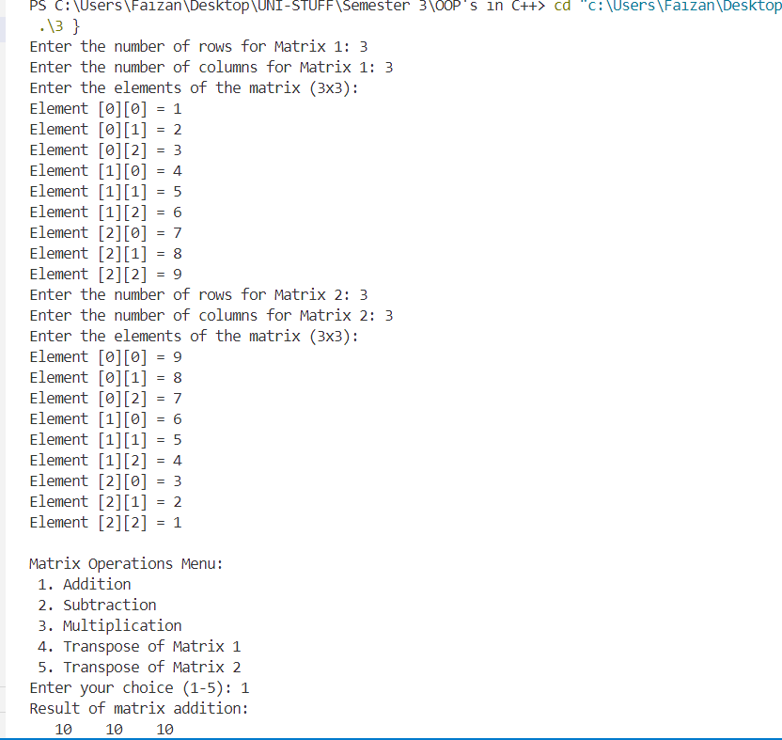

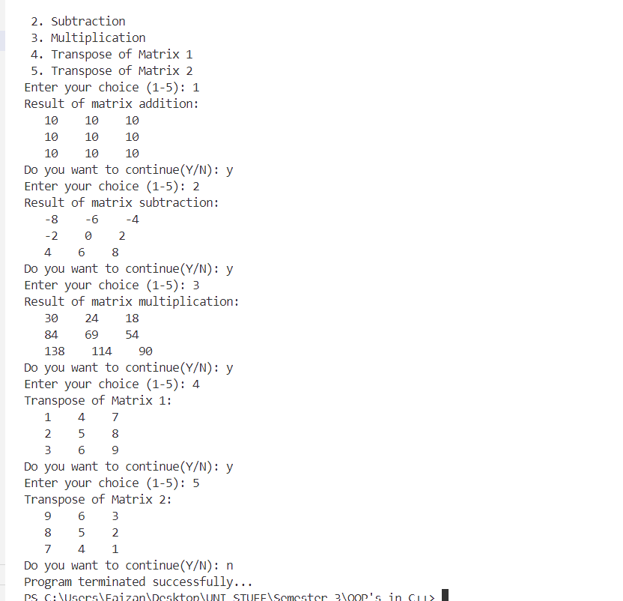

**Lab 4**

**Program:**

Define a class whose attributes are radius, length, and width. Calculate the perimeter of a rectangle and circle. Use constructors and destructors.

**Source Code:**

#include <iostream>

using namespace std;

class Shape {

private:

    double radius, length, width;

public:

    Shape(double r) : radius(r), length(0), width(0) {

        cout << "Circle object created!" << endl;

    }

    Shape(double l, double w) : radius(0), length(l), width(w) {

        cout << "Rectangle object created!" << endl;

    }

    double circlePerimeter() {

        return 2 * 3.1416 * radius;

    }

    double rectanglePerimeter() {

        return 2 * (length + width);

    }

    ~Shape() {

        cout << "Shape object destroyed!" << endl;

    }

};

int main() {

    double r;

    cout << "Enter the radius of the circle: ";

    cin >> r;

    Shape circle(r);

    cout << "Perimeter of the circle: " << circle.circlePerimeter() << endl;

    double l, w;

    cout << "\nEnter the length of the rectangle: ";

    cin >> l;

    cout << "Enter the width of the rectangle: ";

    cin >> w;

    Shape rectangle(l, w);

    cout << "Perimeter of the rectangle: " << rectangle.rectanglePerimeter() << endl;

    cout << "Program terminated successfully..." << endl;

    return 0;

}

**Output:**

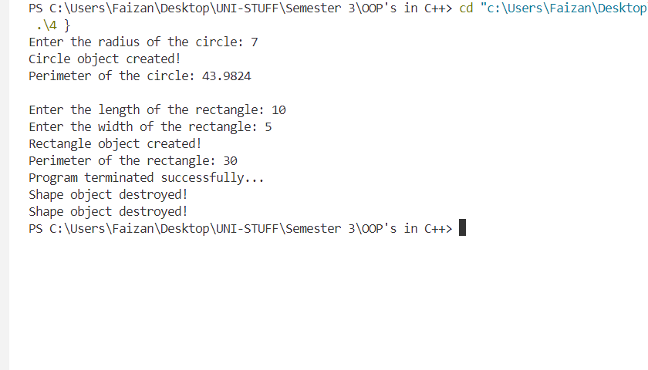

**Lab 5**

**Program:**

Create a class Person which includes a character array name of size 64, age in numeric, character array address of size 64, and total salary in real numbers (divide salary in different components, if required). Make an array of objects of class Person of size 10.

* Write an inline function that obtains the youngest and eldest of a person from a class person using arrays.
* Write a program to generate a salary slip and display result by using constructures.

**Source Code:**

#include <iostream>

#include <cstring>

using namespace std;

class Person {

private:

    char name[64];

    int age;

    char address[64];

    float basicSalary;

    float hra;

    float da;

    float totalSalary;

public:

    Person(const char* n, int a, const char* addr, float basic) {

        strcpy(name, n);

        age = a;

        strcpy(address, addr);

        basicSalary = basic;

        hra = 0.2 * basicSalary;

        da = 0.1 * basicSalary;

        totalSalary = basicSalary + hra + da;

    }

    inline int getAge() const {

        return age;

    }

    inline void displaySalarySlip() const {

        cout << "-------------------------------\n";

        cout << "Salary Slip for " << name << ":\n";

        cout << "Address: " << address << endl;

        cout << "Basic Salary: " << basicSalary << endl;

        cout << "HRA (20%): " << hra << endl;

        cout << "DA (10%): " << da << endl;

        cout << "Total Salary: " << totalSalary << endl;

        cout << "-------------------------------\n";

    }

    static inline Person* findYoungest(Person persons[], int size) {

        Person* youngest = &persons[0];

        for (int i = 1; i < size; ++i) {

            if (persons[i].getAge() < youngest->getAge()) {

                youngest = &persons[i];

            }

        }

        return youngest;

    }

    static inline Person* findEldest(Person persons[], int size) {

        Person* eldest = &persons[0];

        for (int i = 1; i < size; ++i) {

            if (persons[i].getAge() > eldest->getAge()) {

                eldest = &persons[i];

            }

        }

        return eldest;

    }

};

int main() {

    Person persons[10] = {

        Person("John Doe", 28, "123 Street A", 30000),

        Person("Jane Smith", 35, "456 Street B", 45000),

        Person("Alice Green", 24, "789 Street C", 25000),

        Person("Bob Brown", 45, "101 Street D", 60000),

        Person("Charlie Blue", 30, "102 Street E", 32000),

        Person("David White", 40, "103 Street F", 50000),

        Person("Emma Black", 50, "104 Street G", 55000),

        Person("Frank Red", 23, "105 Street H", 27000),

        Person("Grace Yellow", 31, "106 Street I", 40000),

        Person("Hannah Purple", 38, "107 Street J", 47000)

    };

    Person* youngest = Person::findYoungest(persons, 10);

    cout << "The youngest person is:\n";

    youngest->displaySalarySlip();

    Person* eldest = Person::findEldest(persons, 10);

    cout << "The eldest person is:\n";

    eldest->displaySalarySlip();

    cout << "\nSalary slips of all persons:\n";

    for (int i = 0; i < 10; ++i) {

        persons[i].displaySalarySlip();

    }

    cout << "Program terminated successfully..." << endl;

    return 0;

}

**Output:**

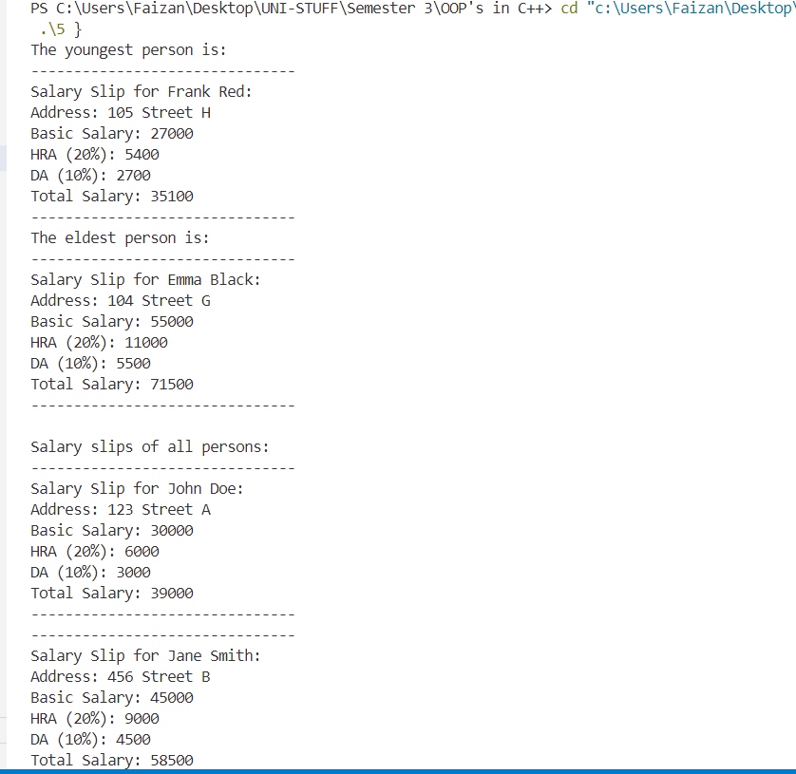

**Lab 6**

**Program:**

Create a class called Complex to perform the following operations:

* Overload increment and decrement operators for increasing and decreasing complex number values (unary operator overload).
* Overload the ‘+’ operator and ‘-’ operator for complex numbers (binary operator overloading).

**Source Code:**

#include <iostream>

using namespace std;

class Complex {

private:

    float real, imag;

public:

    Complex(float r = 0, float i = 0) : real(r), imag(i) {}

    void input() {

        cout << "Enter real part: ";

        cin >> real;

        cout << "Enter imaginary part: ";

        cin >> imag;

    }

    void display() const {

        if (imag >= 0)

            cout << real << " + " << imag << "i" << endl;

        else

            cout << real << " - " << -imag << "i" << endl;

    }

    Complex& operator++() {

        ++real;

        ++imag;

        return *this;

    }

    Complex& operator--() {

        --real;

        --imag;

        return *this;

    }

    Complex operator+(const Complex& c) const {

        Complex temp;

        temp.real = real + c.real;

        temp.imag = imag + c.imag;

        return temp;

    }

    Complex operator-(const Complex& c) const {

        Complex temp;

        temp.real = real - c.real;

        temp.imag = imag - c.imag;

        return temp;

    }

};

int main() {

    Complex c1, c2, result;

    cout << "Enter the first complex number:\n";

    c1.input();

    cout << "\nEnter the second complex number:\n";

    c2.input();

    cout << "\nComplex Number 1: ";

    c1.display();

    cout << "Complex Number 2: ";

    c2.display();

    cout << "\nIncrementing Complex Number 1: ";

    ++c1;

    c1.display();

    cout << "Decrementing Complex Number 2: ";

    --c2;

    c2.display();

    result = c1 + c2;

    cout << "\nSum of Complex Number 1 and 2: ";

    result.display();

    result = c1 - c2;

    cout << "Difference of Complex Number 1 and 2: ";

    result.display();

    cout << "Program terminated successfully..." << endl;

    return 0;

}

**Output:**

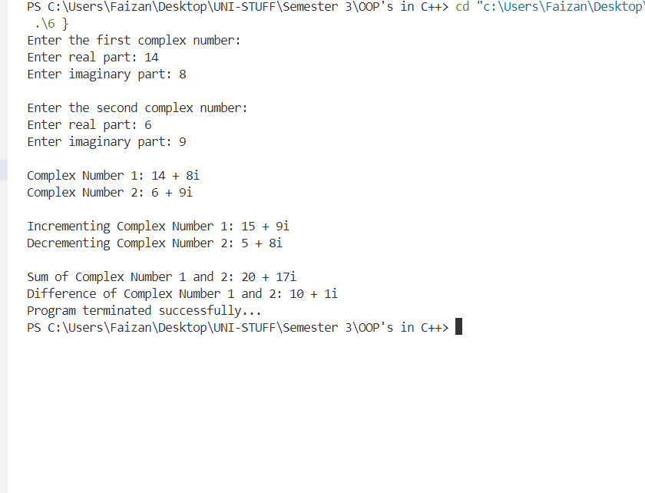

**Lab 7**

**Program:**

Write a program to find the area (function name AREA) of circle, rectangle, and triangle by function overloading concept.

**Source Code:**

#include <iostream>

#include <cmath>

using namespace std;

class Shape {

public:

    double AREA(double radius) {

        return M_PI * pow(radius, 2);

    }

    double AREA(double length, double width) {

        return length * width;

    }

    double AREA(double base, double height, bool isTriangle) {

        if (isTriangle)

            return 0.5 * base * height;

        return 0;

    }

};

int main() {

    Shape shape;

    double radius, length, width, base, height;

    cout << "Enter the radius of the circle: ";

    cin >> radius;

    cout << "Area of the circle: " << shape.AREA(radius) << endl;

    cout << "\nEnter the length of the rectangle: ";

    cin >> length;

    cout << "Enter the width of the rectangle: ";

    cin >> width;

    cout << "Area of the rectangle: " << shape.AREA(length, width) << endl;

    cout << "\nEnter the base of the triangle: ";

    cin >> base;

    cout << "Enter the height of the triangle: ";

    cin >> height;

    cout << "Area of the triangle: " << shape.AREA(base, height, true) << endl;

    cout << "Program terminated successfully..." << endl;

    return 0;

}

**Output:**

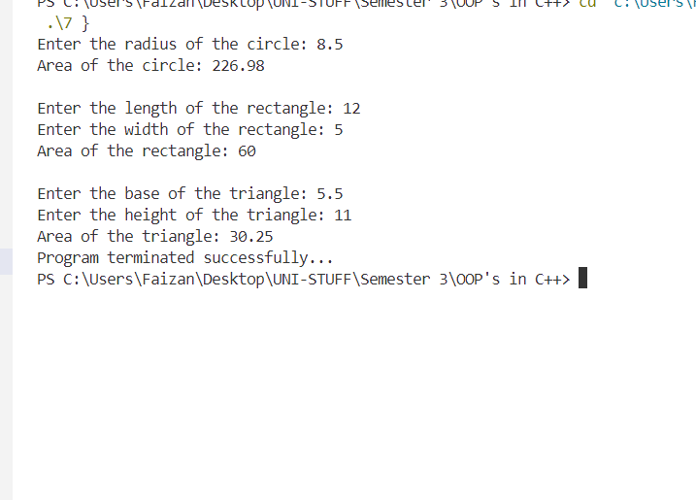

**Lab 8**

**Program:**

Design three classes: Student, Exam, and Result. The Student class has data members such as name, roll number, etc. Create a class Exam by inheriting the Student class. The Exam class adds data members representing marks scored in six subjects. Derive the Result class from the Exam class and it has its own data members such as total marks. Write an interactive program to model this relationship. What type of inheritance does this program belong to?

**Source Code:**

#include <iostream>

using namespace std;

class Student {

protected:

    string name;

    int rollNumber;

public:

    void getStudentDetails() {

        cout << "Enter student name: ";

        cin >> name;

        cout << "Enter roll number: ";

        cin >> rollNumber;

    }

    void displayStudentDetails() {

        cout << "Student Name: " << name << endl;

        cout << "Roll Number: " << rollNumber << endl;

    }

};

class Exam : public Student {

protected:

    float marks[6];

public:

    void getMarks() {

        cout << "Enter marks for 6 subjects: " << endl;

        for (int i = 0; i < 6; i++) {

            cout << "Subject " << i + 1 << ": ";

            cin >> marks[i];

        }

    }

    void displayMarks() {

        cout << "Marks in 6 subjects: " << endl;

        for (int i = 0; i < 6; i++) {

            cout << "Subject " << i + 1 << ": " << marks[i] << endl;

        }

    }

};

class Result : public Exam {

private:

    float totalMarks;

    char grade;

    float averagePercentage, percentage;

public:

    void total() {

        totalMarks = 0;

        for (int i = 0; i < 6; i++) {

            totalMarks += marks[i];

        }

    }

    void assignGrade() {

        if (averagePercentage > 95 && averagePercentage <= 100) {

            grade = 'A+';

        } else if (averagePercentage > 90 && averagePercentage <= 95) {

            grade = 'A';

        } else if (averagePercentage > 80 && averagePercentage <= 90) {

            grade = 'B';

        } else if (averagePercentage > 70 && averagePercentage <= 80) {

            grade = 'C';

        } else if (averagePercentage > 60 && averagePercentage <= 70) {

            grade = 'D';

        } else {

            grade = 'F';

        }

    }

    void calcPercentAvg() {

        cout << "Percentage Marks in each subject: " << endl;

        for (int i = 0; i < 6; i++) {

            percentage = (marks[i] / 100) * 100;

            cout << "Subject " << i + 1 << ": " << percentage << "%" << endl;

        }

        averagePercentage = totalMarks / 6;

        cout << "Average Percentage: " << averagePercentage << "%" << endl;

        assignGrade();

    }

    void displayResult() {

        displayStudentDetails();

        displayMarks();

        cout << "Total Marks: " << totalMarks << endl;

        calcPercentAvg();

        cout << "Grade: " << grade << endl;

    }

};

int main() {

    Result s1;

    s1.getStudentDetails();

    s1.getMarks();

    s1.total();

    cout << "\n--- Result ---\n";

    s1.displayResult();

    cout << "Program terminated successfully..." << endl;

    return 0;

}

**Output:**

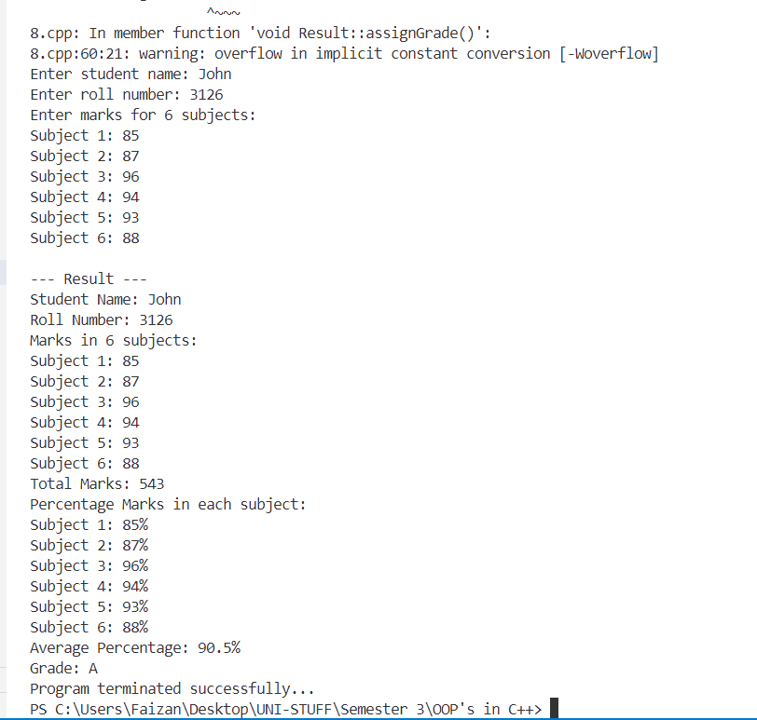

**Lab 9**

**Program:**

Write a program to swap two numbers (create two classes) by using a friend function.

**Source Code:**

#include <iostream>

using namespace std;

class Second;

class First {

private:

    int num1;

public:

    First(int n) : num1(n) {}

    void display() {

        cout << "Number 1: " << num1 << endl;

    }

    friend void swapNumbers(First &f, Second &s);

};

class Second {

private:

    int num2;

public:

    Second(int n) : num2(n) {}

    void display() {

        cout << "Number 2: " << num2 << endl;

    }

    friend void swapNumbers(First &f, Second &s);

};

void swapNumbers(First &f, Second &s) {

    int temp = f.num1;

    f.num1 = s.num2;

    s.num2 = temp;

}

int main() {

    int a, b;

    cout << "Enter the first number: ";

    cin >> a;

    cout << "Enter the second number: ";

    cin >> b;

    First first(a);

    Second second(b);

    cout << "\nBefore swapping:" << endl;

    first.display();

    second.display();

    swapNumbers(first, second);

    cout << "\nAfter swapping:" << endl;

    first.display();

    second.display();

    cout << "Program terminated successfully..." << endl;

    return 0;

}

**Output:**

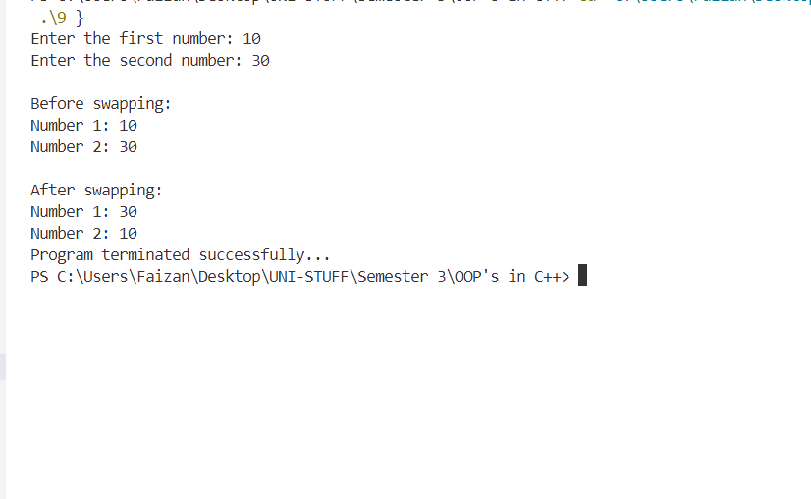

**Lab 10**

**Program:**

Consider an example of a book shop that sells books and video tapes. These two classes are inherited from the base class called media. The media class has command data members such as title and publication. The book class has data members for storing the number of pages in a book and the tape class has playing time in each tape. Each class will have member functions such as read() and show(). In the base class, these members have to be defined as virtual functions.

Write a program that models the hierarchy for a book shop and processes the objects of the classes using pointers to base class. Write the rules of virtual functions.

**Source Code:**

#include <iostream>

#include <string>

using namespace std;

class Media {

protected:

    string title;

    string publication;

public:

    virtual void read() {

        cout << "Enter title: ";

        cin.ignore();

        getline(cin, title);

        cout << "Enter publication: ";

        getline(cin, publication);

    }

    virtual void show() {

        cout << "Title: " << title << endl;

        cout << "Publication: " << publication << endl;

    }

    virtual ~Media() {}

};

class Book : public Media {

private:

    int numPages;

public:

    void read() override {

        Media::read();

        cout << "Enter number of pages: ";

        cin >> numPages;

    }

    void show() override {

        Media::show();

        cout << "Number of pages: " << numPages << endl;

    }

};

class Tape : public Media {

private:

    float playTime;

public:

    void read() override {

        Media::read();

        cout << "Enter playing time (in minutes): ";

        cin >> playTime;

    }

    void show() override {

        Media::show();

        cout << "Playing time: " << playTime << " minutes" << endl;

    }

};

int main() {

    const int size = 4;

    Media* mediaList[size];

    for (int i = 0; i < size; i++) {

        int choice;

        cout << "\nEnter 1 for Book, 2 for Tape: ";

        cin >> choice;

        if (choice == 1) {

            mediaList[i] = new Book();

        } else {

            mediaList[i] = new Tape();

        }

        mediaList[i]->read();

    }

    cout << "\nMedia Details:\n";

    for (int i = 0; i < size; i++) {

        mediaList[i]->show();

        cout << endl;

        delete mediaList[i];

    }

    cout << "Program terminated successfully..." << endl;

    return 0;

}

**Output:**

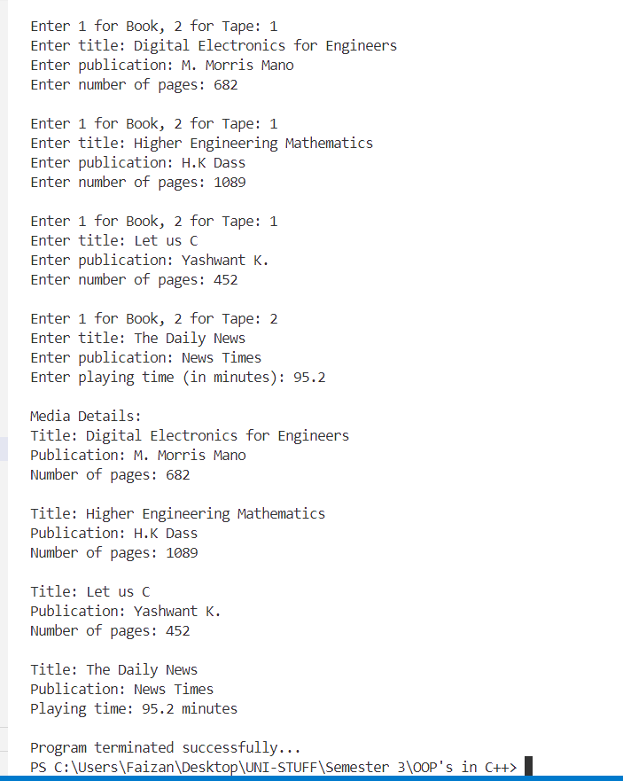

**Lab 11**

**Program:**

Write a program to find the total marks of a student using the concept of virtual base class.

**Source Code:**

#include <iostream>

using namespace std;

class Student {

protected:

    string name;

    int rollNumber;

public:

    Student() {

        cout << "Enter student name: ";

        cin.ignore();

        getline(cin, name);

        cout << "Enter roll number: ";

        cin >> rollNumber;

    }

};

class Exam : virtual public Student {

public:

    int marks1, marks2, marks3;

    void inputMarks() {

        cout << "Enter marks for subject 1: ";

        cin >> marks1;

        cout << "Enter marks for subject 2: ";

        cin >> marks2;

        cout << "Enter marks for subject 3: ";

        cin >> marks3;

    }

};

class Result : virtual public Student {

private:

    int totalMarks;

public:

    void calculateTotalMarks(Exam &exam) {

        totalMarks = exam.marks1 + exam.marks2 + exam.marks3;

    }

    void displayResult() {

        cout << "Total Marks for " << name << " (Roll Number: " << rollNumber << "): " << totalMarks << endl;

    }

};

int main() {

    Exam exam;

    exam.inputMarks();

    Result result;

    result.calculateTotalMarks(exam);

    result.displayResult();

    cout << "Program terminated successfully..." << endl;

    return 0;

}

**Output:**

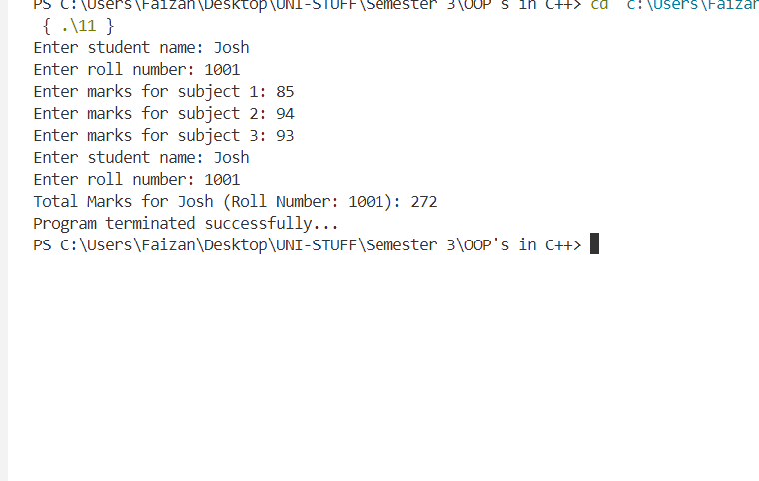

**Lab 12**

**Program:**

Write a program to show the use of ‘this’ pointer. Write the application of this pointer.

**Source Code:**

#include <iostream>

using namespace std;

class Box {

private:

    int length;

    int width;

    int height;

public:

    Box(int l, int w, int h) {

        this->length = l;

        this->width = w;

        this->height = h;

    }

    int volume() {

        return this->length * this->width * this->height;

    }

    bool isLargerThan(Box &b) {

        return this->volume() > b.volume();

    }

    void display() {

        cout << "Length: " << this->length << ", Width: " << this->width << ", Height: " << this->height << endl;

    }

};

int main() {

    Box box1(3, 4, 5);

    Box box2(2, 6, 4);

    cout << "Box 1 dimensions: ";

    box1.display();

    cout << "Volume of Box 1: " << box1.volume() << endl;

    cout << "Box 2 dimensions: ";

    box2.display();

    cout << "Volume of Box 2: " << box2.volume() << endl;

    if (box1.isLargerThan(box2)) {

        cout << "Box 1 is larger than Box 2." << endl;

    } else {

        cout << "Box 2 is larger than or equal to Box 1." << endl;

    }

    cout << "Program terminated successfully..." << endl;

    return 0;

}

**Output:**

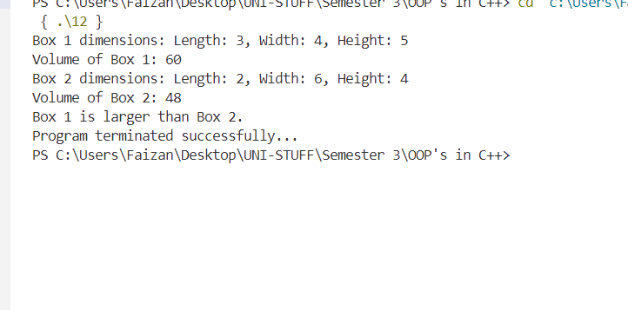

**Lab 13**

**Program:**

Write a program to implement stack functions using templates.

**Source Code:**

#include <iostream>

using namespace std;

template <typename T>

class Stack {

private:

    T* arr;

    int top;

    int capacity;

public:

    Stack(int size) {

        capacity = size;

        arr = new T[capacity];

        top = -1;

    }

    ~Stack() {

        delete[] arr;

    }

    void push(T element) {

        if (top == capacity - 1) {

            cout << "Stack Overflow! Cannot push " << element << endl;

            return;

        }

        arr[++top] = element;

        cout << element << " pushed to stack." << endl;

    }

    T pop() {

        if (top == -1) {

            cout << "Stack Underflow! Cannot pop from an empty stack." << endl;

            return T();

        }

        return arr[top--];

    }

    T peek() {

        if (top == -1) {

            cout << "Stack is empty. Cannot peek." << endl;

            return T();

        }

        return arr[top];

    }

    bool isEmpty() {

        return top == -1;

    }

    int size() {

        return top + 1;

    }

};

int main() {

    Stack<int> intStack(5);

    int choice;

    int element;

        cout << "\nStack Operations Menu:\n";

        cout << "1. Push\n";

        cout << "2. Pop\n";

        cout << "3. Peek\n";

        cout << "4. Check if Empty\n";

        cout << "5. Get Size\n";

        cout << "6. Exit\n";

    do {

        cout << "Select an operation: ";

        cin >> choice;

        switch (choice) {

            case 1:

                cout << "Enter a value to push: ";

                cin >> element;

                intStack.push(element);

                break;

            case 2:

                cout << intStack.pop() << " popped from stack." << endl;

                break;

            case 3:

                cout << "Top element: " << intStack.peek() << endl;

                break;

            case 4:

                if (intStack.isEmpty()) {

                    cout << "Stack is empty." << endl;

                } else {

                    cout << "Stack is not empty." << endl;

                }

                break;

            case 5:

                cout << "Current stack size: " << intStack.size() << endl;

                break;

            case 6:

                cout << "Exiting program." << endl;

                break;

            default:

                cout << "Invalid choice. Please select again." << endl;

                break;

        }

    } while (choice != 6);

    cout << "Program terminated successflly..." << endl;

    return 0;

}

**Output:**

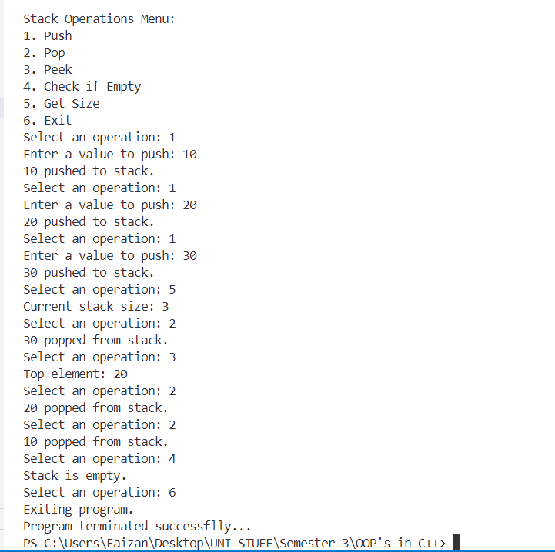

**Lab 14**

**Program:**

Write a program to demonstrate exception handling.

**Source Code:**

#include <iostream>

using namespace std;

class DivisionException : public exception {

public:

    const char* what() const noexcept override {

        return "Error: Division by zero.";

    }

};

double divide(double numerator, double denominator) {

    if (denominator == 0) {

        throw DivisionException();

    }

    return numerator / denominator;

}

int main() {

    double num1, num2;

    cout << "Enter numerator: ";

    cin >> num1;

    cout << "Enter denominator: ";

    cin >> num2;

    try {

        double result = divide(num1, num2);

        cout << "Result: " << result << endl;

    } catch (const DivisionException& e) {

        cout << e.what() << endl;

    } catch (const exception& e) {

        cout << "An error occurred: " << e.what() << endl;

    }

    cout << "Program terminated successfully..." << endl;

    return 0;

}

**Output:**

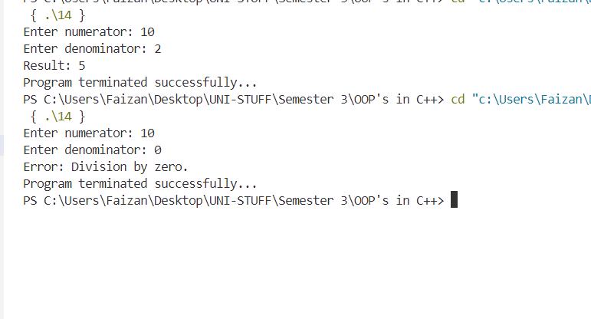

**Lab 15**

**Program:**

Write a program that inputs a file, which determines its length, and also counts the number of word occurrences.

**Source Code:**

#include <iostream>

#include <fstream>

#include <sstream>

#include <map>

#include <string>

using namespace std;

void count(const string& filename) {

    ifstream file(filename);

    if (!file.is_open()) {

        cout << "Error opening file!" << endl;

        return;

    }

    string line;

    int charCount = 0;

    map<string, int> wordCount;

    while (getline(file, line)) {

        charCount += line.length();

        stringstream ss(line);

        string word;

        while (ss >> word) {

            wordCount[word]++;

        }

    }

    file.close();

    cout << "Character count: " << charCount << endl;

    cout << "Word occurrences:" << endl;

    for (const auto& entry : wordCount) {

        cout << entry.first << ": " << entry.second << endl;

    }

}

int main() {

    string filename;

    cout << "Enter the filename: ";

    cin >> filename;

    count(filename);

    return 0;

}

**Output:**

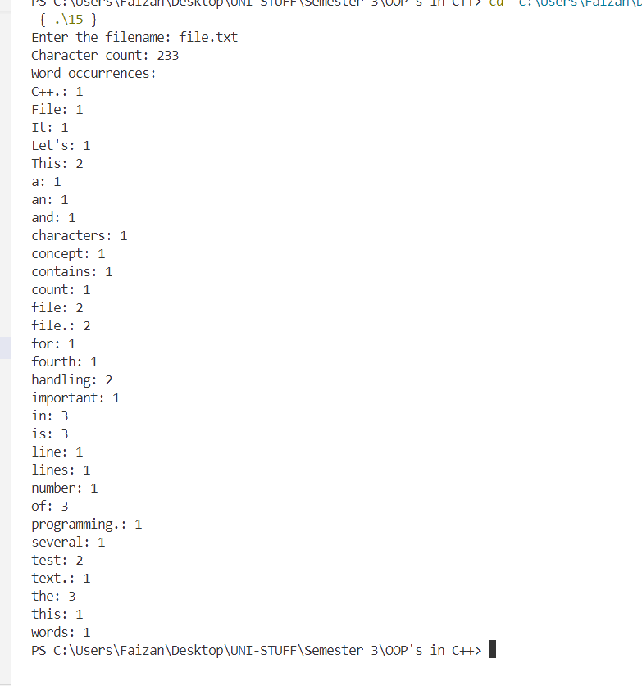

**Lab 16**

**Program:**

Write a program to demonstrate file handling: Creating a binary file to store student details.

**Source Code:**

#include <iostream>

#include <fstream>

#include <string>

using namespace std;

struct Student {

    char name[50];

    int rollNumber;

    float marks;

};

void writeToFile(const string& filename) {

    ofstream outFile(filename, ios::binary);

    if (!outFile) {

        cout << "Error opening file for writing!" << endl;

        return;

    }

    Student student;

    char choice;

    do {

        cout << "Enter student name: ";

        cin >> student.name;

        cout << "Enter roll number: ";

        cin >> student.rollNumber;

        cout << "Enter marks: ";

        cin >> student.marks;

        outFile.write(reinterpret_cast<char*>(&student), sizeof(student));

        cout << "Do you want to add another student? (y/n): ";

        cin >> choice;

    } while (choice == 'y' || choice == 'Y');

    outFile.close();

    cout << "Student details saved to file." << endl;

}

void readFromFile(const string& filename) {

    ifstream inFile(filename, ios::binary);

    if (!inFile) {

        cout << "Error opening file for reading!" << endl;

        return;

    }

    Student student;

    cout << "\nStudent Details:\n";

    while (inFile.read(reinterpret_cast<char*>(&student), sizeof(student))) {

        cout << "Name: " << student.name << ", Roll Number: " << student.rollNumber << ", Marks: " << student.marks << endl;

    }

    inFile.close();

}

int main() {

    string filename = "students.dat";

    writeToFile(filename);

    readFromFile(filename);

    return 0;

**Output:**

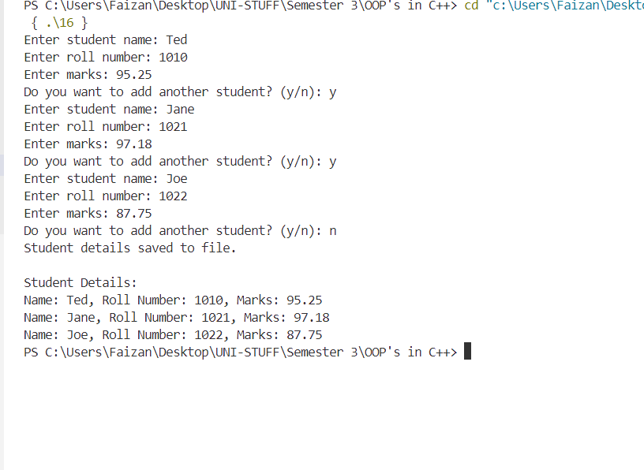

**Lab 17**

**Program:**

Take time of two zones, current time of city 1 and current time of city 2. Calculate the time difference between two cities. Use the concept of passing objects as parameters.

**Source Code:**

#include <iostream>

using namespace std;

class Time {

private:

    int hours;

    int minutes;

public:

    Time(int h = 0, int m = 0) : hours(h), minutes(m) {}

    void display() const {

        cout << (hours < 10 ? "0" : "") << hours << ":"

             << (minutes < 10 ? "0" : "") << minutes;

    }

    Time timeDifference(const Time& other) const {

        int totalMinutes1 = hours * 60 + minutes;

        int totalMinutes2 = other.hours * 60 + other.minutes;

        int diffMinutes = totalMinutes1 - totalMinutes2;

        if (diffMinutes < 0) {

            diffMinutes += 24 * 60;

        }

        return Time(diffMinutes / 60, diffMinutes % 60);

    }

};

int main() {

    int h1, m1, h2, m2;

    cout << "Enter current time of city 1 (hours minutes): ";

    cin >> h1 >> m1;

    Time city1(h1, m1);

    cout << "Enter current time of city 2 (hours minutes): ";

    cin >> h2 >> m2;

    Time city2(h2, m2);

    Time difference = city1.timeDifference(city2);

    cout << "Time difference between city 1 and city 2 is: ";

    difference.display();

    cout << "Program terminated successfully..." << endl;

    return 0;

}

**Output:**

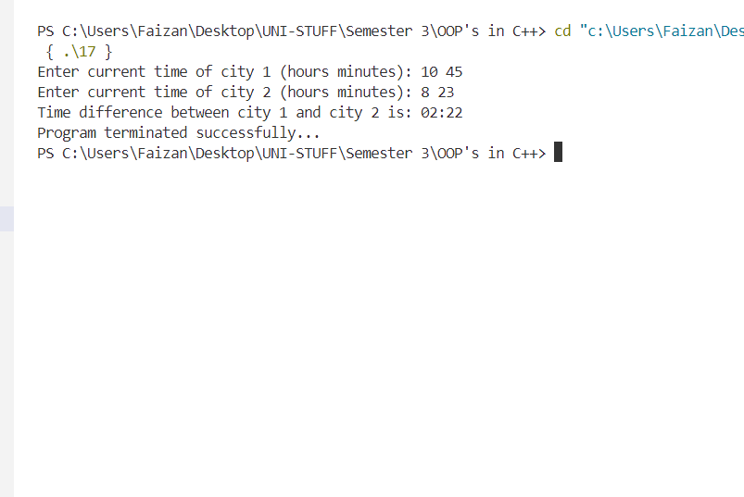

**Lab 18**

**Program:**

Write a macro to obtain the largest of three numbers. Do the same using an inline function.

**Source Code:**

#include <iostream>

using namespace std;

#define MAX(a, b, c) ((a) > (b) ? ((a) > (c) ? (a) : (c)) : ((b) > (c) ? (b) : (c)))

inline int max(int a, int b, int c) {

    return (a > b) ? ((a > c) ? a : c) : ((b > c) ? b : c);

}

int main() {

    int x, y, z;

    cout << "Enter x: ";

    cin >> x;

    cout << "Enter y: ";

    cin >> y;

    cout << "Enter z: ";

    cin >> z;

    int maxNumMacro = MAX(x, y, z);

    int maxNumInline = max(x, y, z);

    cout << "Largest number using macro: " << maxNumMacro << endl;

    cout << "Largest number using inline function: " << maxNumInline << endl;

    return 0;

}

**Output:**

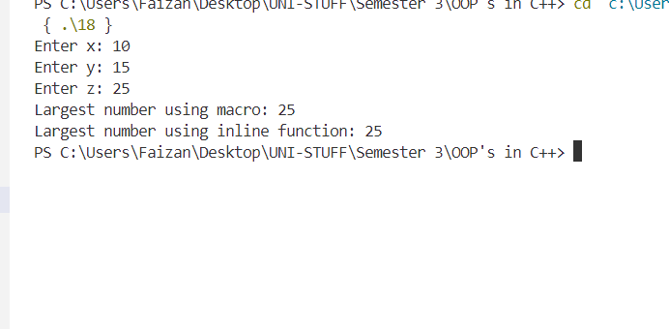

**Lab 19**

**Program:**

Write a C++ program to implement a class called BankAccount that has private member variables for account number and balance. Include member functions to deposit and withdraw money from the account.. Use appropriate inheritance for classes such as Bank, Customer, and Employee. Include functions for customers balance, bank total balance, withdraw, deposit, total customers in bank, account information, and functions to create new customer accounts by taking details such as name, account number, address, etc.

**Source Code:**

#include <iostream>

using namespace std;

class Customer {

    string name;

    int account_No;

    int balance = 0; // Each customer's balance is initialized to 0

    static int total_customers;

    static int Bank_balance;

public:

    void details();

    void deposit();

    void withdraw();

    void show_customers();

    void show_balance();

};

int Customer::total_customers = 0;

int Customer::Bank_balance = 0;

void Customer::details() {

    cout << "Enter name: ";

    cin >> name;

    cout << "Enter account no.: ";

    cin >> account_No;

    total_customers++;

    cout << "Total customers in bank: " << total_customers << endl;

}

void Customer::deposit() {

    int deposit_amount;

    cout << "Enter amount to deposit: ";

    cin >> deposit_amount;

    balance += deposit_amount;  // Update the customer's balance directly

    Bank_balance += deposit_amount;  // Update bank's balance

    cout << "Amount deposited: " << deposit_amount << endl;

    cout << "Current Balance: " << balance << endl;

}

void Customer::withdraw() {

    int withdraw_amount;

    cout << "Enter amount to withdraw: ";

    cin >> withdraw_amount;

    if (withdraw_amount > balance) {

        cout << "Insufficient balance..." << endl;

    } else {

        balance -= withdraw_amount;  // Update the customer's balance directly

        Bank_balance -= withdraw_amount;  // Update bank's balance

        cout << "Amount withdrawn: " << withdraw_amount << endl;

        cout << "Current Balance: " << balance << endl;

    }

}

void Customer::show_customers() {

    cout << "Total customers: " << total_customers << endl;

    cout << "Bank Total Balance: " << Bank_balance << endl;

}

void Customer::show_balance() {

    cout << "Balance is: " << balance << endl;

}

int main() {

    Customer c1, c2, c3;

    char repeat;

    // Get details of customers

    c1.details();

    c2.details();

    c3.details();

    do {

        int customer;

        char action;

        cout << "Enter customer number (1-3): ";

        cin >> customer;

        switch (customer) {

            case 1:

                cout << "To Deposit press (d)." << endl << "To Withdraw press (w)." << endl << "To check balance press (b)." << endl;

                cin >> action;

                switch (action) {

                    case 'd':

                        c1.deposit();

                        break;

                    case 'w':

                        c1.withdraw();

                        break;

                    case 'b':

                        c1.show_balance();

                        break;

                    default:

                        cout << "Action not correct..." << endl;

                        break;

                }

                break;

            case 2:

                cout << "To Deposit press (d)." << endl << "To Withdraw press (w)." << endl << "To check balance press (b)." << endl;

                cin >> action;

                switch (action) {

                    case 'd':

                        c2.deposit();

                        break;

                    case 'w':

                        c2.withdraw();

                        break;

                    case 'b':

                        c2.show_balance();

                        break;

                    default:

                        cout << "Action not correct..." << endl;

                        break;

                }

                break;

            case 3:

                cout << "To Deposit press (d)." << endl << "To Withdraw press (w)." << endl << "To check balance press (b)." << endl;

                cin >> action;

                switch (action) {

                    case 'd':

                        c3.deposit();

                        break;

                    case 'w':

                        c3.withdraw();

                        break;

                    case 'b':

                        c3.show_balance();

                        break;

                    default:

                        cout << "Action not correct..." << endl;

                        break;

                }

                break;

            default:

                cout << "Invalid customer number." << endl;

                break;

        }

        cout << "Do you want to continue (Y/N): ";

        cin >> repeat;

    } while (repeat == 'Y' || repeat == 'y');

    return 0;

}

**Output:**

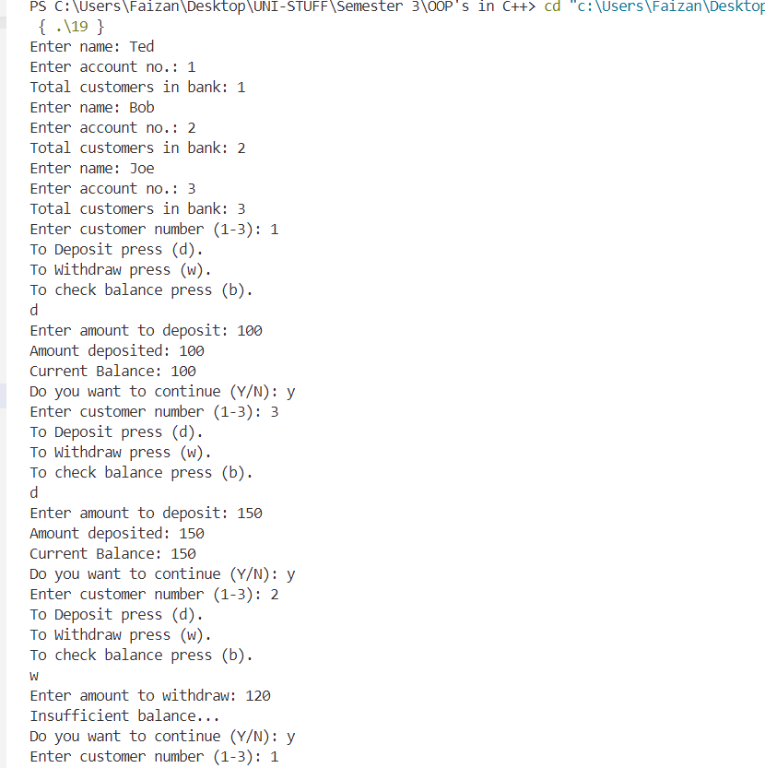

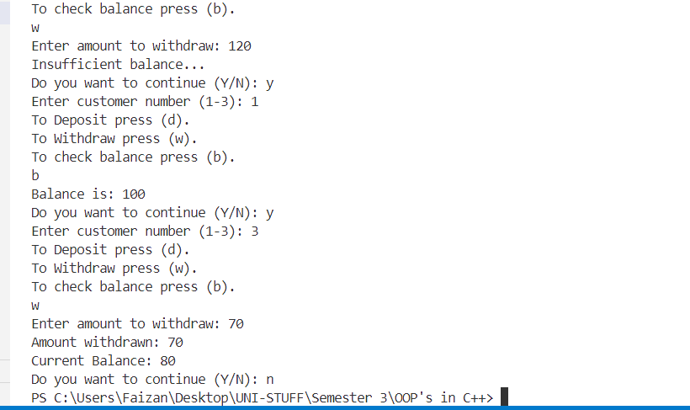

**Lab 20**

**Program:**

Write a C++ program to create a class called Triangle that has private member variables for the lengths of its three sides. Implement member functions to determine if the triangle is equilateral, isosceles, or scalene.

**Source Code:**

#include<iostream>

using namespace std;

class Triangle {

    float l1;

    float l2;

    float l3;

    public:

        void setLengths();

        void type();

};

void Triangle::setLengths()

{

    cout << "Enter lenght 1: ";

    cin >> l1;

    cout << "Enter length 2: ";

    cin >> l2;

    cout << "Enter length 3: ";

    cin >> l3;

}

void Triangle::type()

{

    if(l1 == l2 && l2 == l3) {

        cout << "Equilateral triangle.";

    }

    else if(l1 == l2 || l2 == l3 || l3 == l1)

    {

        cout << "Isosceles triangle.";

    }

    else if(l1 != l2 && l2 != l3 && l3 != l1)

    {

        cout << "Scalene triangle.";

    }

}

int main()

{

    Triangle t;

    t.setLengths();

    t.type();

    return 0;

}

**Output:**

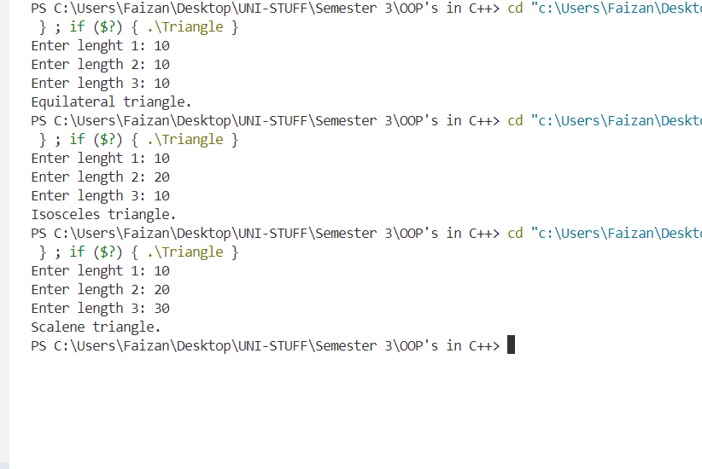

**Lab 21**

**Program:**

Create a class called “TIME” that has three integer data members for hours, minutes

and seconds. The class should have a constructor to initialize the object to zero and a constructor to initialize the object to some constant value. The class should have member function to add two TIME objects and member function to display time in HH:MM:SS format. Write a main function to create two TIME objects, add them and display the result in HH:MM:SS format.

**Source Code:**

#include <iostream>

using namespace std;

class TIME {

private:

    int hours;

    int minutes;

    int seconds;

public:

    TIME() : hours(0), minutes(0), seconds(0) {}

    TIME(int h, int m, int s) : hours(h), minutes(m), seconds(s) {

        normalize();

    }

    void normalize() {

        if (seconds >= 60) {

            minutes += seconds / 60;

            seconds = seconds % 60;

        }

        if (minutes >= 60) {

            hours += minutes / 60;

            minutes = minutes % 60;

        }

    }

    TIME add(const TIME& other) const {

        TIME result;

        result.hours = hours + other.hours;

        result.minutes = minutes + other.minutes;

        result.seconds = seconds + other.seconds;

        result.normalize();

        return result;

    }

    void display() const {

        cout << "Time: " << hours << " : " << minutes << " : " << seconds << endl;

    }

    void input() {

        cout << "Enter hours: ";

        cin >> hours;

        cout << "Enter minutes: ";

        cin >> minutes;

        cout << "Enter seconds: ";

        cin >> seconds;

        normalize();

    }

};

int main() {

    TIME time1, time2;

    cout << "Enter time for first object:\n";

    time1.input();

    cout << "Enter time for second object:\n";

    time2.input();

    TIME totalTime = time1.add(time2);

    totalTime.display();

    return 0;

}

**Output:** 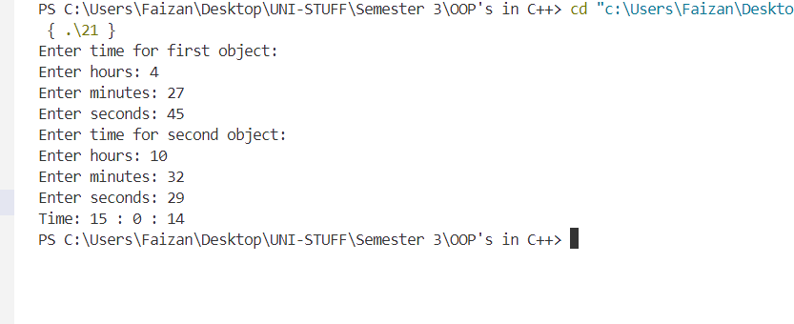

**Lab 22**

**Program:**

Create a class box having data member object_count as static. Create a constructor that initializes the data members length, breadth and height and define function volume. Also, create a static member function to display the number of objects created.

**Source Code:**

#include <iostream>

#include <vector>  // Include the vector header

using namespace std;

class Box {

private:

    float length;

    float breadth;

    float height;

    static int object_count;

public:

    Box() : length(0), breadth(0), height(0) {

        object_count++;

    }

    Box(float l, float b, float h) : length(l), breadth(b), height(h) {

        object_count++;

    }

    float volume() const {

        return length * breadth * height;

    }

    static void displayObjectCount() {

        cout << "Number of Box objects created: " << object_count << endl;

    }

};

int Box::object_count = 0;

int main() {

    int n;

    cout << "Enter the number of boxes: ";

    cin >> n;

    vector<Box> boxes;  // Using vector to store Box objects

    float length, breadth, height;

    for (int i = 0; i < n; ++i) {

        cout << "Enter dimensions for Box " << (i + 1) << ":\n";

        cout << "Length: ";

        cin >> length;

        cout << "Breadth: ";

        cin >> breadth;

        cout << "Height: ";

        cin >> height;

        boxes.emplace_back(length, breadth, height);  // Use emplace_back to create Box objects directly in the vector

    }

    for (int i = 0; i < n; ++i) {

        cout << "Volume of Box " << (i + 1) << ": " << boxes[i].volume() << endl;

    }

    Box::displayObjectCount();

    return 0;

}

**Output:**

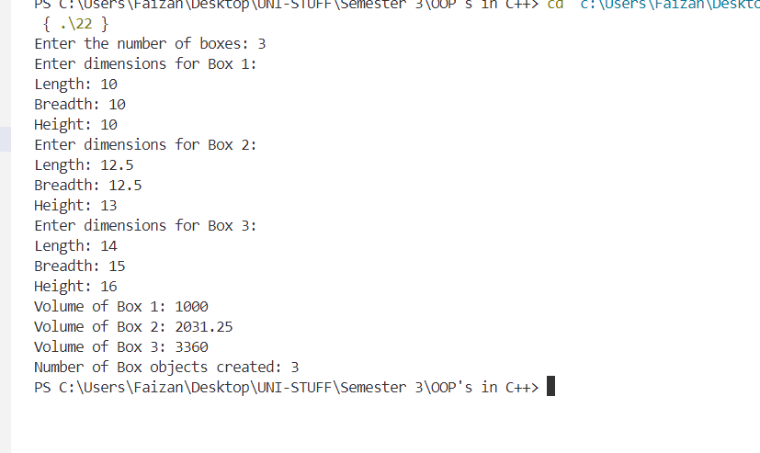

**Lab 23**

**Program:**

Write a program to implement the following inheritances:

* Single inheritance
* Multiple inheritance
* Hierarchical inheritance
* Multilevel inheritance
* Hybrid inheritance

**Source Code:**

#include <iostream>

using namespace std;

class Arithmetic {

public:

    float add(float a, float b) {

        return a + b;

    }

    float subtract(float a, float b) {

        return a - b;

    }

    float multiply(float a, float b) {

        return a * b;

    }

    float divide(float a, float b) {

        if (b != 0)

            return a / b;

        else {

            cout << "Division by zero error!" << endl;

            return 0;

        }

    }

};

class BasicOperations : public Arithmetic {

public:

    void performBasicOperations(float a, float b) {

        cout << "Addition: " << add(a, b) << endl;

        cout << "Subtraction: " << subtract(a, b) << endl;

    }

};

class AdvancedOperations {

public:

    void performAdvancedOperations(float a, float b) {

        Arithmetic arith;

        cout << "Multiplication: " << arith.multiply(a, b) << endl;

        cout << "Division: " << arith.divide(a, b) << endl;

    }

};

class Operations : public BasicOperations, public AdvancedOperations {

public:

    void performAllOperations(float a, float b) {

        performBasicOperations(a, b);

        performAdvancedOperations(a, b);

    }

};

class MoreOperations : public Arithmetic {

public:

    void performMoreOperations(float a, float b) {

        cout << "Addition (MoreOperations): " << add(a, b) << endl;

    }

};

class ExtendedOperations : public MoreOperations {

public:

    void performExtendedOperations(float a, float b) {

        cout << "Subtraction (ExtendedOperations): " << subtract(a, b) << endl;

    }

};

class HybridOperations : public BasicOperations, public ExtendedOperations {

public:

    void performHybridOperations(float a, float b) {

        Operations op;

        op.performAllOperations(a, b);

        performExtendedOperations(a, b);

    }

};

int main() {

    float a, b;

    cout << "Enter value for a: ";

    cin >> a;

    cout << "Enter value for b: ";

    cin >> b;

    cout << "\nUsing Operations class for all operations:\n";

    Operations op;

    op.performAllOperations(a, b);

    cout << "\nUsing ExtendedOperations class:\n";

    ExtendedOperations extOp;

    extOp.performExtendedOperations(a, b);

    cout << "\nUsing HybridOperations class:\n";

    HybridOperations hybridOp;

    hybridOp.performHybridOperations(a, b);

    return 0;

}

**Output:**

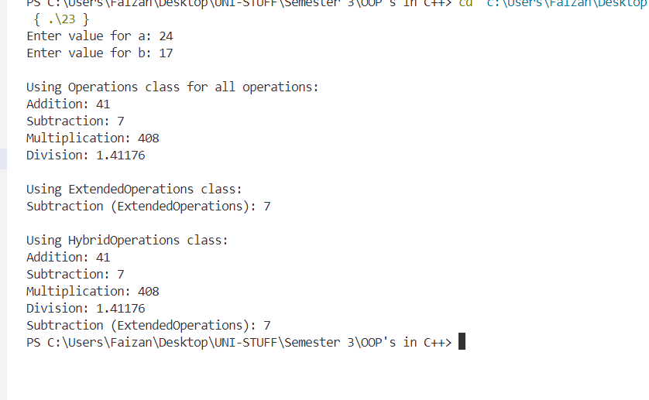

**Lab 24**

**Program:**

Write a program to implement the functions of a simple calculator using functions and switch cases.

**Source Code:**

#include<iostream>

#include<cmath>

using namespace std;

class Calculator {

        float a;

        float b;

    public:

        void result();

        float add();

        float subtract();

        float multiply();

        float divide();

};

void Calculator::result()

{

    cout << "Enter a value for A: ";

    cin >> a;

    cout << "Enter a value for B: ";

    cin >> b;

}

float Calculator::add()

{

    return a + b;

}

float Calculator::subtract()

{

    return a - b;

}

float Calculator::multiply()

{

    return a * b;

}

float Calculator::divide()

{

    if(b == 0) {

        cout << "Division by 0...\n";

        return INFINITY;

    }

    else {

        return a / b;

    }

}

int main()

{

    char contn;

    char symbol;

    Calculator c;

    cout << "********** Simple Calculator **********\n";

    cout << "\nChoose required operation: " << "\n"

    "Enter \'+\' to add a and b." << "\n"

    "Enter \'-\' to subtract a and b." << "\n"

    "Enter \'*\' to multiply a and b." << "\n"

    "Enter \'/\' to divide a and b." << "\n";

    do {

    cout << "\nEnter operator: ";

    cin >> symbol;

    switch(symbol) {

        case '+':

            c.result();

            cout << "Addition is: " << c.add() << endl;

            break;

        case '-':

            c.result();

            cout << "Subtraction is: " << c.subtract() << endl;

            break;

        case '*':

            c.result();

            cout << "Multiplication is: " << c.multiply() << endl;

            break;

        case '/':

            c.result();

            cout << "Division is: " << c.divide() << endl;

            break;

        default:

            cout << "Choose from the given operators...\n" <<

            "INCORRECT OPERATOR!" << endl;

            break;

    }

    cout << "\nDo you want to continue (Y/N): ";

    cin >> contn;

    } while(contn == 'Y' || contn == 'y');

    return 0;

}

**Output:**

